

FACULTY OF TECHNOLOGY AND ENGINEERING
DEVANG PATEL INSTITUTE OF ADVANCE TECHNOLOGY AND RESEARCH
DEPARTMENT OF INFORMATION TECHNOLOGY

A.Y. 2026-27 [ODD]
LAB MANUAL
CSUC201: DSA



Practical 5.1 :

Problem statement :

A music player maintains a playlist where songs can be added to the beginning, added to the
end, or inserted right after a specific song that is currently playing. When a song is removed,
only the first song in the playlist is dropped. At any point the player can count how many songs
are in the playlist and display them from first to last. Given a sequence of such operations,
implement all of them on a doubly linked playlist and print the result after each operation.
Describe how your insertion after a given song works. What extra step does a doubly linked list
require here that a singly linked list did not? What happens if the given song is not found in the
playlist?

Code :

https://github.com/vaidik5646/FDSA-BATCH-A/tree/main/practical5

Output :

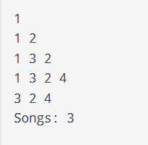

Problem faced :

In this practical I faced the issue is inserting and delete the node and also in this practical how to remove the node in any position.

Key Question :

[Problem 1] A doubly linked list maintains two links per node instead of one. When
deleting the front node, explain why having a backward link on the second node creates
a responsibility that did not exist in a singly linked list — and what goes wrong if you
forget to handle it.

-> When deleting the front node in a doubly linked list, the second node’s backward (prev) link must be updated to null because it should no longer point to the deleted node. In a singly linked list, this responsibility does not exist because nodes have only a next link. If you forget to update the prev link, the second node will still point to the deleted node, causing an invalid or dangling reference and incorrect backward traversal.

Practical 5.2 :

Problem statement :

A group of students are sitting in a circle playing a passing game. A token starts at the first
student and is passed around the circle one student at a time. Students can join the circle at any
position and leave at any time, and the circle must remain unbroken after every join or leave.
Given a sequence of join, leave, and display operations, implement them on both a singly
circular and a doubly circular linked list and print the current circle after each operation.
Describe how your solution ensures the circle stays unbroken after a student leaves. What is
the one case where breaking the circle is most likely to happen as a bug, and how did you
handle it?

Code :

https://github.com/vaidik5646/FDSA-BATCH-A/tree/main/practical5

Output :

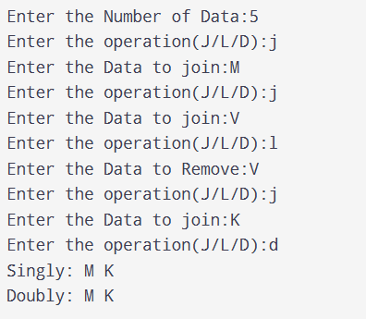

Problem faced :

In this practical I faced the issue is how to join and how to leave and how to display the element in the circular linked list and singly linked list.

Key question :

[Problem 2] If your traversal of the circular list does not stop at the right moment, it will
loop forever. Without referencing any specific code, explain what condition must be true
at the moment you stop, and why that condition would fail if you set the last node's link to
null.

-> In a circular linked list, traversal should stop when you reach the starting (first) node again, because the last node points back to it. This condition would fail if the last node’s link were set to null, because there would be no link back to the starting node, so you could not detect the cycle correctly and traversal would instead stop at null.

